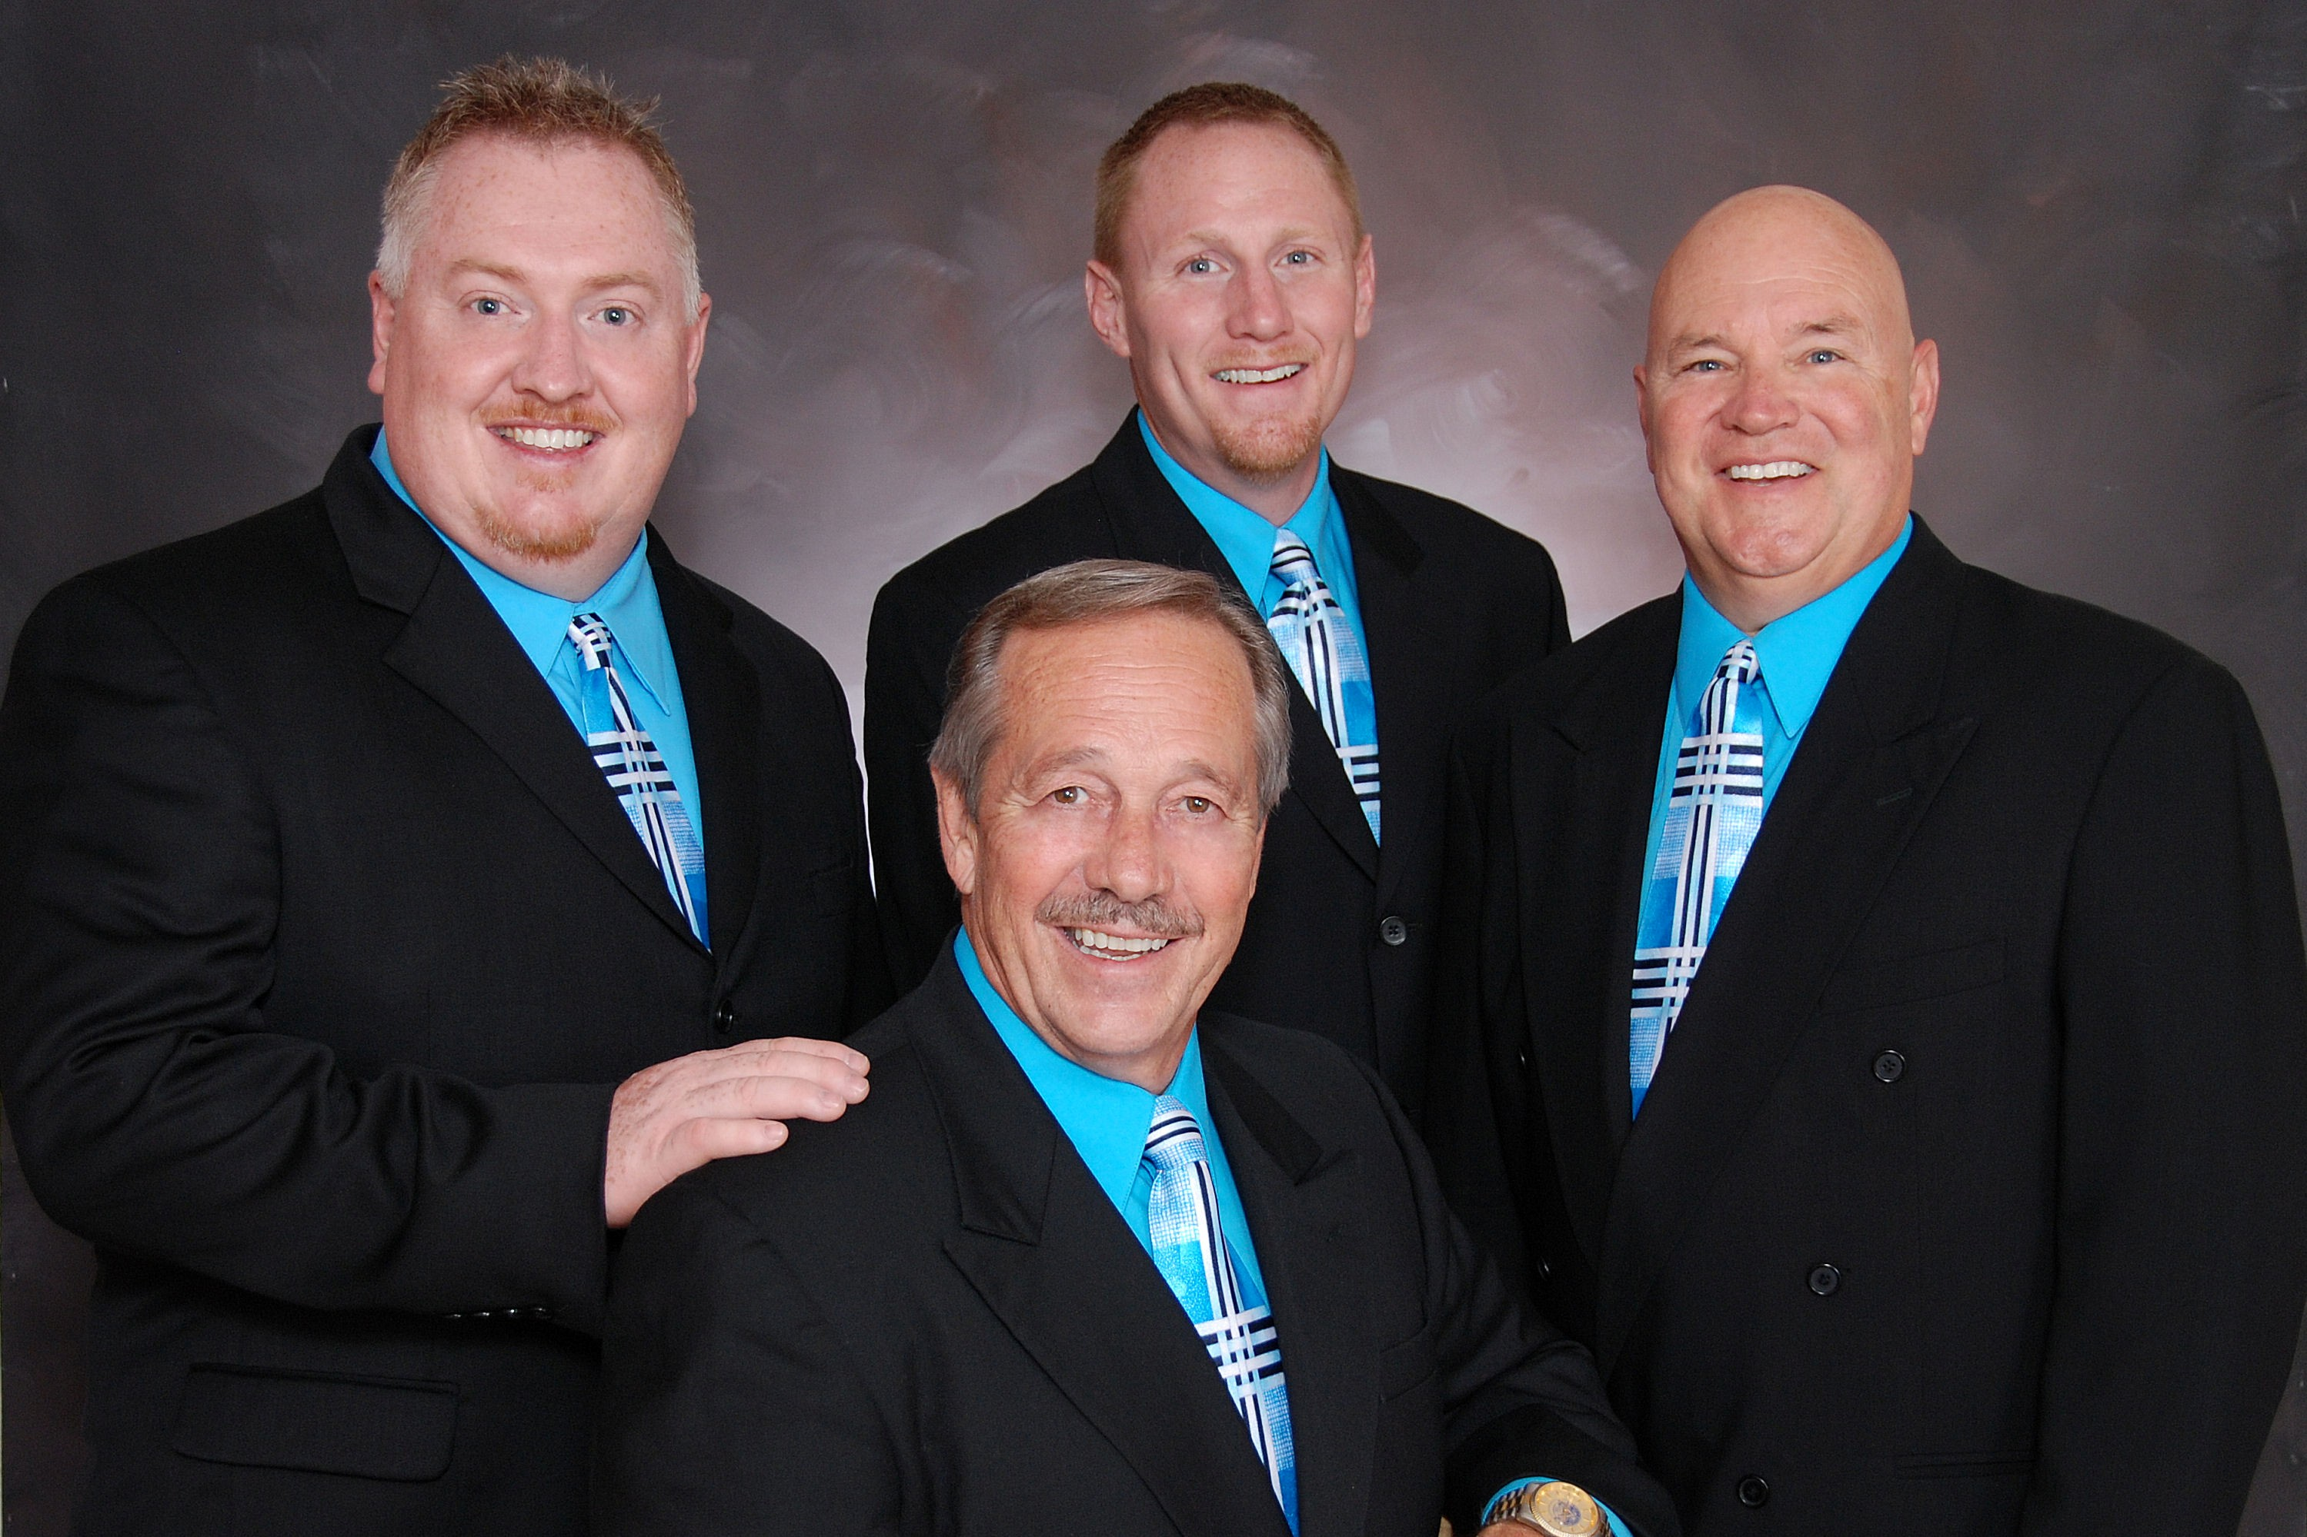

THE AMERICAN
QUARTET

IN CONCERT

